Jenkins pipelines Challenge

Use the below code and implement our CICD stages.
- Source Code: https://github.com/betawins/hiring-app.git
  - Repository contains the application code for the hiring app.
- Create one Declarative pipeline job
- Create one Scripted pipeline job
- Create one multi stage pipeline job
- Create one parallel stage pipeline job
Jenkins Official Documentation
Recommended
- Pipeline: https://www.jenkins.io/doc/book/pipeline/
- Environment Variables: https://www.jenkins.io/doc/book/pipeline/jenkinsfile/#using-environment-variables
- Parameters: https://www.jenkins.io/doc/book/pipeline/syntax/#parameters
- Handling credentials in Pipeline: https://www.jenkins.io/doc/book/pipeline/jenkinsfile/#handling-credentials

- Jenkins Declarative Pipeline – Steps & Notes
Objective
Create a Jenkins Declarative Pipeline for the hiring-app GitHub project and run it on Jenkins-Agent-1.
Repository:
https://github.com/betawins/hiring-app.git
Branch:
main

Step 1: Create a New Jenkins Job
- Open Jenkins.
- Click New Item.
- Job name:
Majeed-hiringapp-declarative
- Select Pipeline.
- Click OK.
Why?
A separate job keeps the new pipeline independent from our previous Jenkins jobs.

Step 2: Configure Pipeline
Go to:
Job → Configure → Pipeline
Select:
Definition: Pipeline script
Enter this pipeline:
pipeline {
agent {
label 'agent-1'
}

stages {
stage('Git Clone') {
steps {
git branch: 'main',
url: 'https://github.com/betawins/hiring-app.git'
}
}

stage('Maven Build') {
steps {
sh 'mvn clean package -DskipTests'
}
}

stage('Test') {
steps {
sh 'mvn test'
}
}
}
}
Click Save.

Step 3: Run the Pipeline
Click:
Build Now
Open the latest build → Console Output.
The pipeline should execute these stages:
Git Clone
↓
Maven Build
↓
Test

Step 4: Verify the Build
Successful Stage View:
Git Clone ✅
Maven Build ✅
Test ✅
Our successful build:
Build #3 — SUCCESS
Stage times were approximately:
- Git Clone → 739 ms
- Maven Build → 18 sec
- Test → 2 sec

What We Learned
1. Declarative Pipeline
Declarative Pipeline uses the structured:
pipeline {
agent {}
stages {}
}
format.
It is easier to read and maintain.
2. Agent
We used:
agent {
label 'agent-1'
}
This tells Jenkins:
Run this pipeline on the Jenkins node having the label agent-1.
Therefore, the actual Git and Maven commands execute on Jenkins-Agent-1, not the Controller.
3. Git Clone
git branch: 'main',
url: 'https://github.com/betawins/hiring-app.git'
This downloads the application source code from GitHub.
We explicitly specified main because Jenkins initially could not determine the correct branch.
4. Maven Build
sh 'mvn clean package -DskipTests'
This cleans the previous Maven build files and creates the application package.
-DskipTests means tests are not executed during this build stage.
5. Test
sh 'mvn test'
This runs the application's Maven tests.

Final Result
Job: Majeed-hiringapp-declarative
Build: #3
Result: ✅ SUCCESS
Stages:
Git Clone → Maven Build → Test
Pipeline Type: Declarative Pipeline
Execution Node: Jenkins-Agent-1
Status: ✅ COMPLETED

Error: The earlier Build #2 failed because Jenkins wasn't finding the correct branch. We fixed that by explicitly specifying:
git branch: 'main',
url: 'https://github.com/betawins/hiring-app.git'
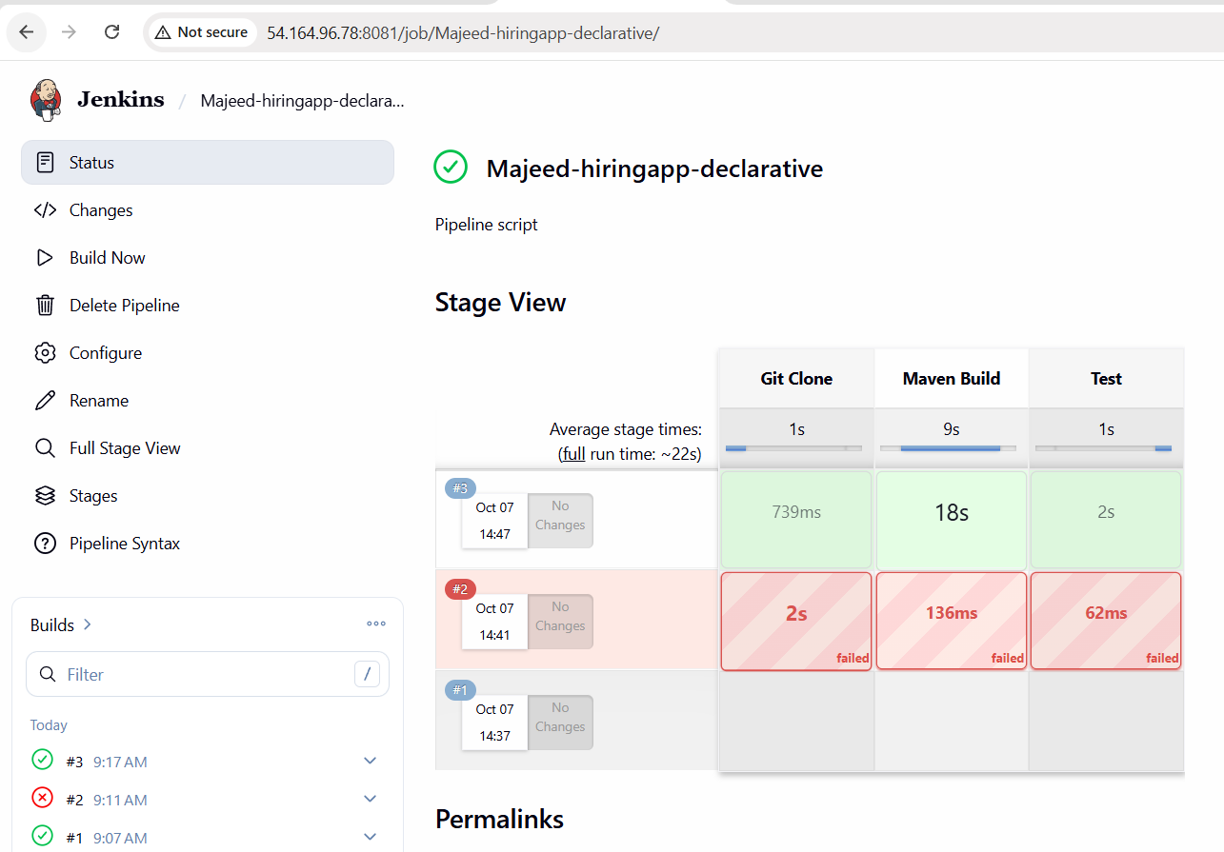
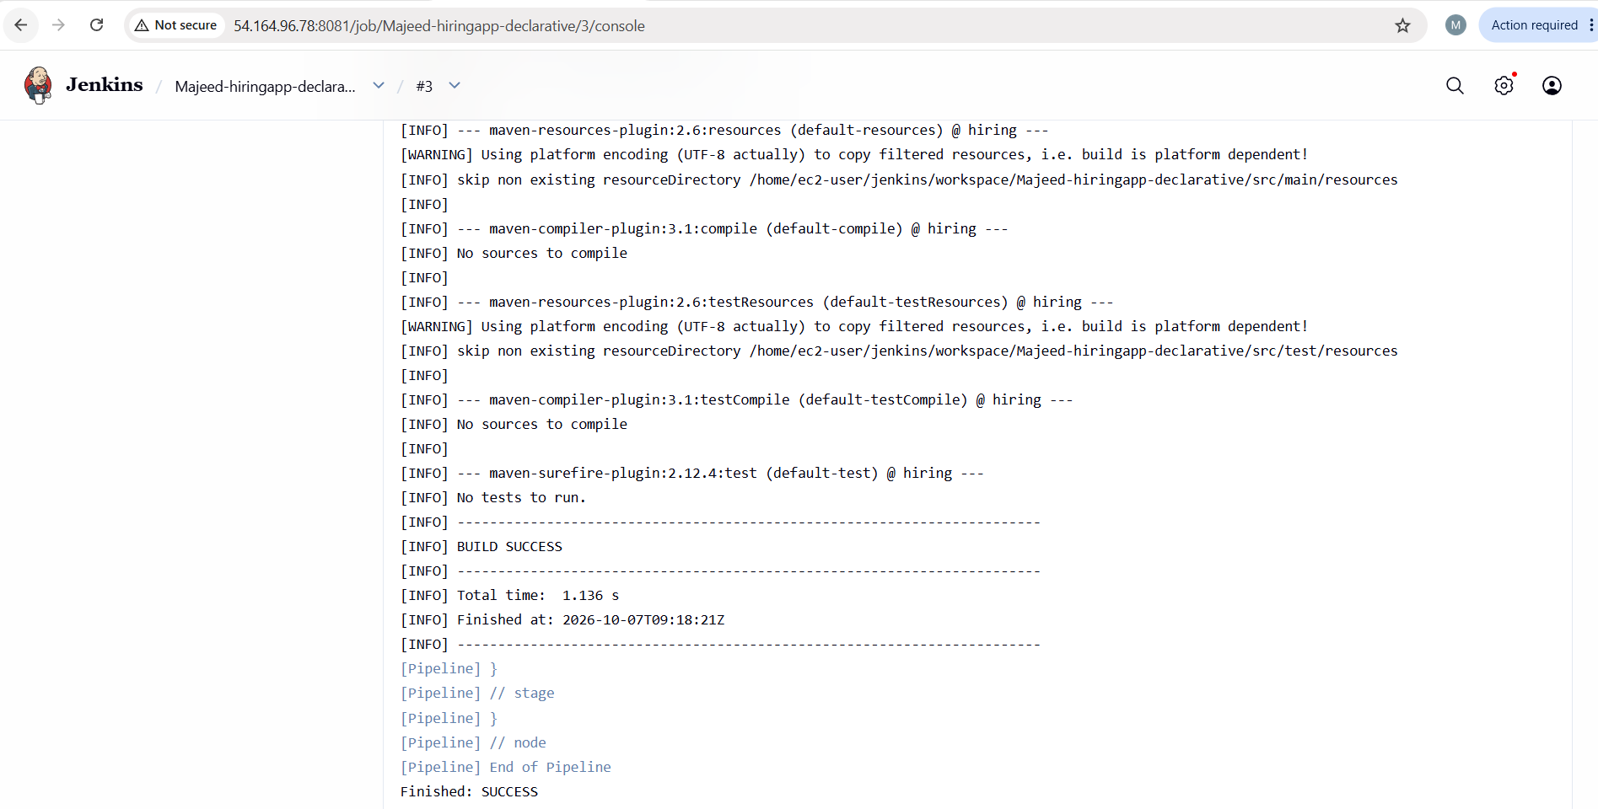

- Jenkins Scripted Pipeline – Steps & Notes
Objective
Create a Jenkins Scripted Pipeline for the hiring-app GitHub project and run it on Jenkins-Agent-1.
Repository:
https://github.com/betawins/hiring-app.git
Branch:
main

Step 1: Create a New Jenkins Job
- Open Jenkins.
- Click New Item.
- Enter the job name:
Majeed-hiringapp-scripted
- Select Pipeline.
- Click OK.
Why?
We create a separate job so that the successful Declarative Pipeline remains unchanged.

Step 2: Configure the Pipeline
Go to:
Job → Configure → Pipeline
Select:
Definition: Pipeline script
Enter:
node('agent-1') {

stage('Git Clone') {
git branch: 'main',
url: 'https://github.com/betawins/hiring-app.git'
}

stage('Maven Build') {
sh 'mvn clean package -DskipTests'
}

stage('Test') {
sh 'mvn test'
}
}
Click Save.

Step 3: Run the Pipeline
Click:
Build Now
Open the latest build and select:
Console Output
The pipeline should execute:
Git Clone
↓
Maven Build
↓
Test

Step 4: Verify the Build
Our successful build was:
Build #1 — SUCCESS
Stage results:
Git Clone ✅ 687 ms
Maven Build ✅ 3 sec
Test ✅ 2 sec
The final console output showed:
[INFO] BUILD SUCCESS
and:
Finished: SUCCESS

What We Learned
1. Scripted Pipeline
A Scripted Pipeline uses Groovy scripting directly.
The basic structure is:
node('agent-1') {
stage('Stage Name') {
// commands
}
}
This is different from the Declarative Pipeline structure.
Declarative
pipeline {
agent {}
stages {}
}
Scripted
node('agent-1') {
stage(...) {
...
}
}

2. node('agent-1')
node('agent-1') {
This tells Jenkins to execute the pipeline on the Jenkins node with the label:
agent-1
Therefore, the Git and Maven commands run on Jenkins-Agent-1.

3. Git Clone Stage
git branch: 'main',
url: 'https://github.com/betawins/hiring-app.git'

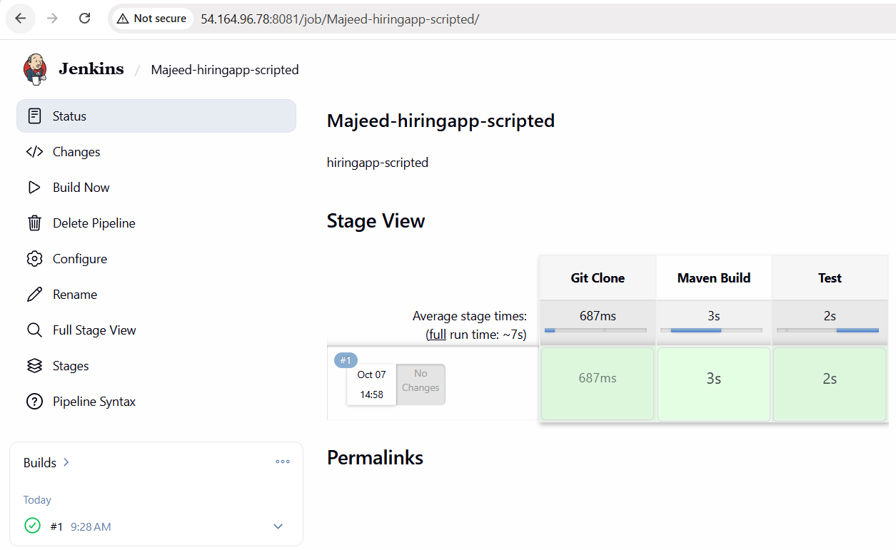
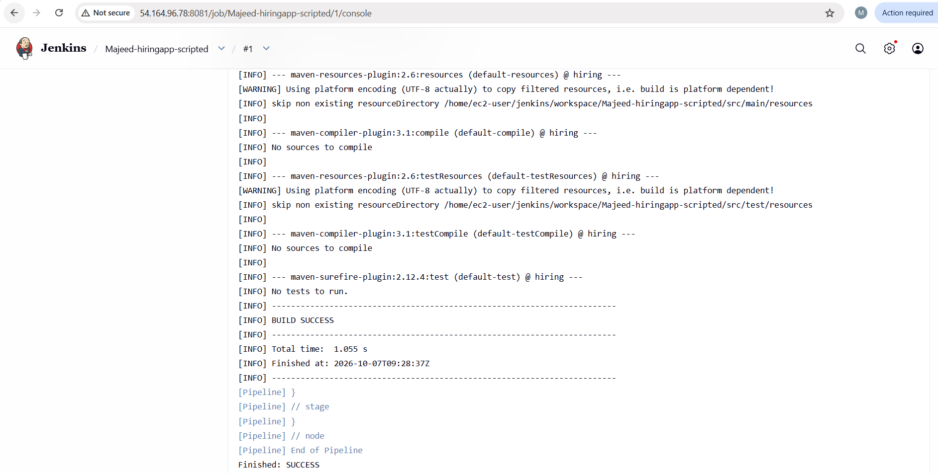
--------------------------------------------------------------------------------------------------------------
- Jenkins Multi-Stage Pipeline – Steps, Notes & Difference

Objective
Create a Jenkins Multi-Stage Pipeline for the hiring-app GitHub project.
Repository:
https://github.com/betawins/hiring-app.git
Branch:
main
The pipeline will contain four separate stages:
Source
↓
Build
↓
Test
↓
Package

Step 1: Create a New Jenkins Job
- Open Jenkins.
- Click New Item.
- Enter:
Majeed-hiringapp-multistage
- Select Pipeline.
- Click OK.
Why?
We create a separate job so our previous successful pipelines remain unchanged.

Step 2: Configure the Pipeline
Go to:
Job → Configure → Pipeline
Select:
Definition: Pipeline script
Enter:
pipeline {
agent {
label 'agent-1'
}

stages {

stage('Source') {
steps {
git branch: 'main',
url: 'https://github.com/betawins/hiring-app.git'
}
}

stage('Build') {
steps {
sh 'mvn clean package -DskipTests'
}
}

stage('Test') {
steps {
sh 'mvn test'
}
}

stage('Package') {
steps {
sh 'ls -lh target/'
}
}
}
}
Click Save.

Step 3: Run the Pipeline
Click:
Build Now
Open the latest build.
Check Stage View or Console Output.
The expected flow is:
Source
↓
Build
↓
Test
↓
Package
Each stage starts after the previous stage finishes.

Step 4: Verify the Build
Our successful build:
Build #1 — SUCCESS
Stage results:
Source ✅ 636 ms
Build ✅ 3 sec
Test ✅ 2 sec
Package ✅ 345 ms
Overall result:
✅ SUCCESS

What Each Stage Does
1. Source
stage('Source') {
steps {
git branch: 'main',
url: 'https://github.com/betawins/hiring-app.git'
}
}
Downloads the source code from GitHub.

2. Build
stage('Build') {
steps {
sh 'mvn clean package -DskipTests'
}
}
Cleans the previous Maven build and creates the application package.
Tests are skipped here because we have a separate Test stage.

3. Test
stage('Test') {
steps {
sh 'mvn test'
}
}
Runs the Maven tests.
For this project, Maven reported that there were no tests to execute, but the command completed successfully.

4. Package
stage('Package') {
steps {
sh 'ls -lh target/'
}
}
Displays the contents of the Maven target directory.
This lets us verify that Maven created the build output.

What Does "Multi-Stage" Mean?
A pipeline can contain multiple stages, with each stage representing a different part of the CI/CD process.
Our pipeline has:
Source → Build → Test → Package
Each stage is clearly visible in Jenkins Stage View.
This makes the pipeline easier to understand and troubleshoot.
For example, if Test fails, we immediately know that the problem occurred during testing.

Difference Between Our 3 Pipelines
Feature | Declarative | Scripted | Multi-Stage
Job | Majeed-hiringapp-declarative | Majeed-hiringapp-scripted | Majeed-hiringapp-multistage
Pipeline style | Declarative | Scripted | Declarative
Main syntax | pipeline {} | node {} | pipeline {}
Agent | agent {} | node('agent-1') | agent {}
Stages | 3 | 3 | 4
Git | ✅ | ✅ | ✅
Maven Build | ✅ | ✅ | ✅
Test | ✅ | ✅ | ✅
Package verification | ❌ | ❌ | ✅
Result | ✅ SUCCESS | ✅ SUCCESS | ✅ SUCCESS

Important Difference
There is a small but important point:
Multi-Stage Pipeline is not a completely different Jenkins pipeline syntax.
It is still a pipeline containing multiple stages.
Our first Declarative Pipeline already had stages:
Git Clone → Maven Build → Test
The Multi-Stage Pipeline expands the CI process into more clearly separated stages:
Source → Build → Test → Package
So the main learning point is how to divide a CI/CD process into meaningful stages.

Sequential Execution
Our Multi-Stage Pipeline runs sequentially:
Source
↓
Build
↓
Test
↓
Package
The next stage waits for the previous stage to finish.
For example:
Source finishes
↓
Build starts
↓
Build finishes
↓
Test starts
↓
Test finishes
↓
Package starts

Why Use Multiple Stages?
Separate stages make a pipeline:
- Easier to read
- Easier to troubleshoot
- Easier to monitor
- Easier to identify failures
- Easier to extend later
For example, later we could add:
Source
↓
Build
↓
Test
↓
SonarQube
↓
Nexus
↓
Deploy

Final Result
Job:
Majeed-hiringapp-multistage
Build:
#1
Pipeline Type:
Multi-Stage Pipeline
Branch:
main
Execution Node:
Jenkins-Agent-1
Stages:
Source → Build → Test → Package
Result:
✅ SUCCESS

Current Challenge Progress
1. Declarative Pipeline ✅ DONE
2. Scripted Pipeline ✅ DONE
3. Multi-Stage Pipeline ✅ DONE
Keep all three completed jobs unchanged. The final task will be a Parallel Stage Pipeline, where independent stages can execute at the same time.

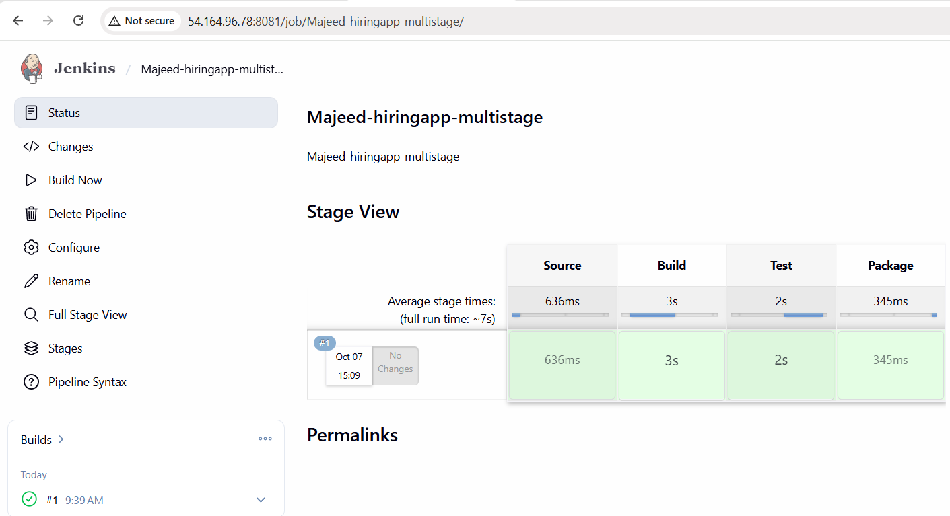
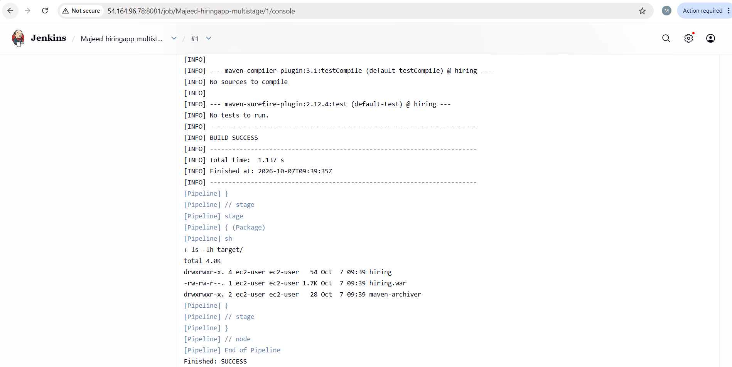
-------------------------------------------------------------------------------------------------------
- Create one parallel stage pipeline job

Concept: This one is important because it introduces a new concept: two independent stages can run at the same time, instead of waiting for one another.

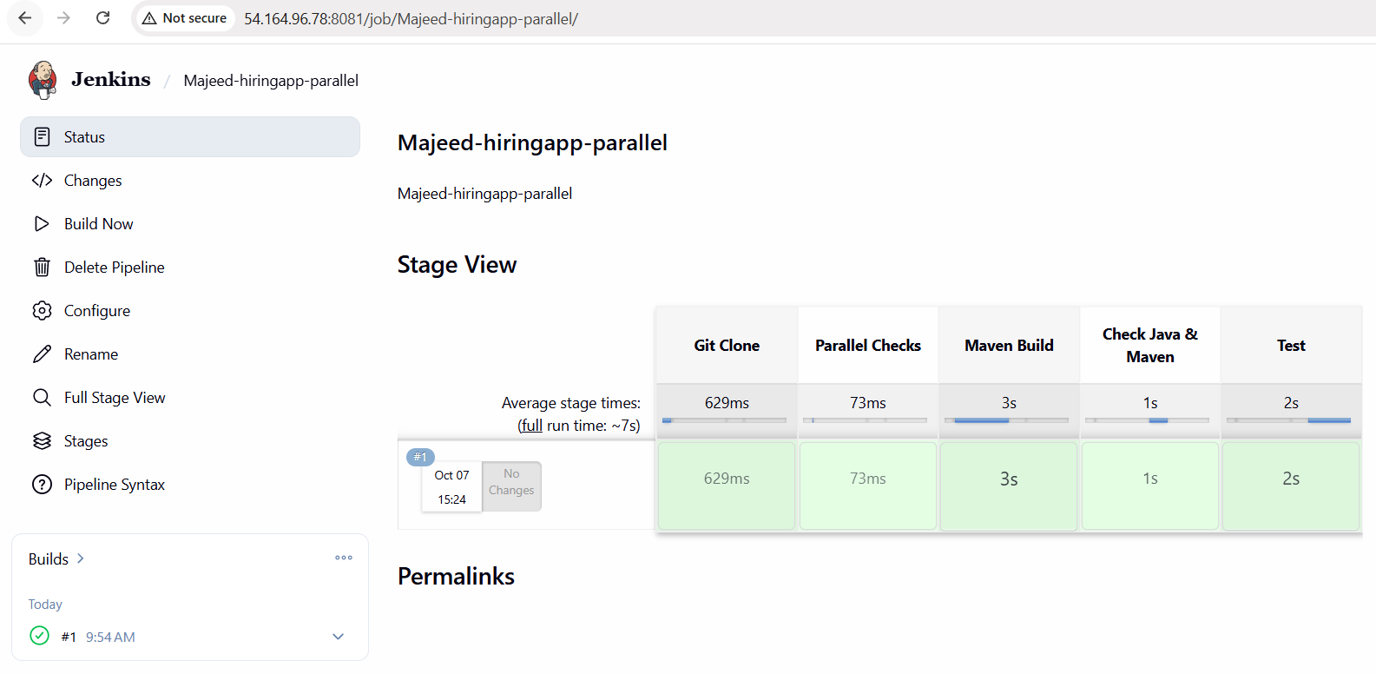
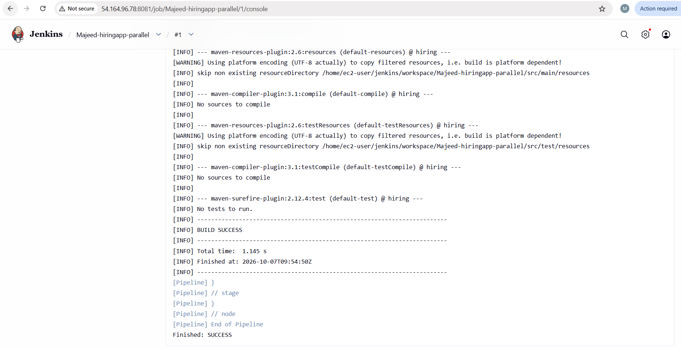

Jenkins Parallel Pipeline – Steps, Notes & Difference
Objective
Create a Jenkins Parallel Stage Pipeline for the hiring-app GitHub project.
Repository:
https://github.com/betawins/hiring-app.git
Branch:
main
The main purpose of this pipeline is to learn how Jenkins can execute independent stages at the same time.

Step 1: Create a New Jenkins Job
- Open Jenkins.
- Click New Item.
- Enter:
Majeed-hiringapp-parallel
- Select Pipeline.
- Click OK.
Why?
We create a separate job so our previously completed pipelines remain unchanged.

Step 2: Configure the Pipeline
Go to:
Job → Configure → Pipeline
Select:
Definition: Pipeline script
Enter:
pipeline {
agent {
label 'agent-1'
}

stages {

stage('Git Clone') {
steps {
git branch: 'main',
url: 'https://github.com/betawins/hiring-app.git'
}
}

stage('Parallel Checks') {
parallel {

stage('Maven Build') {
steps {
sh 'mvn clean package -DskipTests'
}
}

stage('Check Java & Maven') {
steps {
sh 'java -version'
sh 'mvn --version'
}
}
}
}

stage('Test') {
steps {
sh 'mvn test'
}
}
}
}
Click Save.

Step 3: Understand the Pipeline Flow
The pipeline works like this:
┌── Maven Build ──────────┐
Git Clone ───────────────┤ ├── Test
└── Check Java & Maven ────┘
First:
Git Clone
runs.
After Git Clone finishes, Jenkins enters:
Parallel Checks
Inside this stage, two independent stages are executed:
Maven Build
│
│ Parallel
│
Check Java & Maven
After both complete, Jenkins moves to:
Test

Step 4: Run the Pipeline
Click:
Build Now
Open the latest build and check Stage View.
Expected stages:
Git Clone ✅
Parallel Checks ✅
Maven Build ✅
Check Java & Maven ✅
Test ✅

Step 5: Verify the Successful Build
Our successful build:
Build #1 — SUCCESS
Stage times:
Git Clone ✅ 629 ms
Parallel Checks ✅
Maven Build ✅ 3 sec
Check Java & Maven ✅ 1 sec
Test ✅ 2 sec
Overall:
✅ SUCCESS

What Each Stage Does
1. Git Clone
stage('Git Clone') {
steps {
git branch: 'main',
url: 'https://github.com/betawins/hiring-app.git'
}
}
Downloads the hiring-app source code from GitHub.
The pipeline specifically uses the:
main
branch.

2. Parallel Checks
stage('Parallel Checks') {
parallel {
...
}
}
This is the most important part of this task.
The parallel block tells Jenkins that the stages inside it are independent and can run at the same time.

3. Maven Build
stage('Maven Build') {
steps {
sh 'mvn clean package -DskipTests'
}
}
Cleans and builds the application.
Tests are skipped during this build because testing is handled separately.

4. Check Java & Maven
stage('Check Java & Maven') {
steps {
sh 'java -version'
sh 'mvn --version'
}
}
Checks the Java and Maven versions installed on Jenkins-Agent-1.
This is useful for verifying that the build environment has the required tools.

5. Test
stage('Test') {
steps {
sh 'mvn test'
}
}
Runs the Maven test command after the parallel checks have completed.
For this project, Maven reported that there were no tests to execute. This is not a Jenkins pipeline failure.

What Does Parallel Mean?
Normally, stages run one after another:
Stage A
↓
Stage B
↓
Stage C
Parallel execution allows independent stages to run at the same time:
┌── Stage B ──┐
Stage A ─────┤ ├──── Stage D
└── Stage C ──┘
In our pipeline:
┌── Maven Build ────────┐
Git Clone ───┤ ├── Test
└── Java & Maven Check ─┘

Why Use Parallel Stages?
Parallel execution can:
- Reduce total pipeline execution time
- Run independent checks simultaneously
- Improve CI/CD efficiency
- Separate independent tasks
- Make large pipelines faster
For example, in a real CI/CD pipeline, we might run:

┌── Unit Tests ──────┐
Build ─────────── ─ SonarQube Scan ──┼── Deploy
└── Security Scan ───┘
If these tasks don't depend on each other, they can potentially run in parallel.

Difference: Sequential vs Parallel
Multi-Stage Pipeline
Our Multi-Stage Pipeline was sequential:
Source
↓
Build
↓
Test
↓
Package
Each stage waits for the previous stage.

Parallel Pipeline
Our Parallel Pipeline:
┌── Maven Build ────────┐
Git Clone ───┤ ├── Test
└── Java & Maven Check ─┘
Two independent stages can run concurrently.

Difference Between All Four Pipelines
Pipeline | Main Concept | Execution
Declarative | Declarative syntax | Sequential
Scripted | Groovy/scripted syntax | Sequential
Multi-Stage | More clearly separated stages | Sequential
Parallel | Independent stages | Parallel
Simple way to remember
Declarative:
How we define the pipeline.
Scripted:
Another way of writing the pipeline using Groovy.
Multi-Stage:
Divide the CI/CD process into multiple meaningful stages.
Parallel:
Run independent stages at the same time.

Final Result
Job:
Majeed-hiringapp-parallel
Build:
#1
Pipeline Type:
Parallel Stage Pipeline
Branch:
main
Execution Node:
Jenkins-Agent-1
Result:
✅ SUCCESS

Complete Challenge Result
1. Declarative Pipeline
Majeed-hiringapp-declarative
Build #3
✅ SUCCESS

2. Scripted Pipeline
Majeed-hiringapp-scripted
Build #1
✅ SUCCESS

3. Multi-Stage Pipeline
Majeed-hiringapp-multistage
Build #1
✅ SUCCESS

4. Parallel Stage Pipeline
Majeed-hiringapp-parallel
Build #1
✅ SUCCESS
Final Status
🎯 All 4 Jenkins Pipeline tasks are completed successfully.

